

open web page
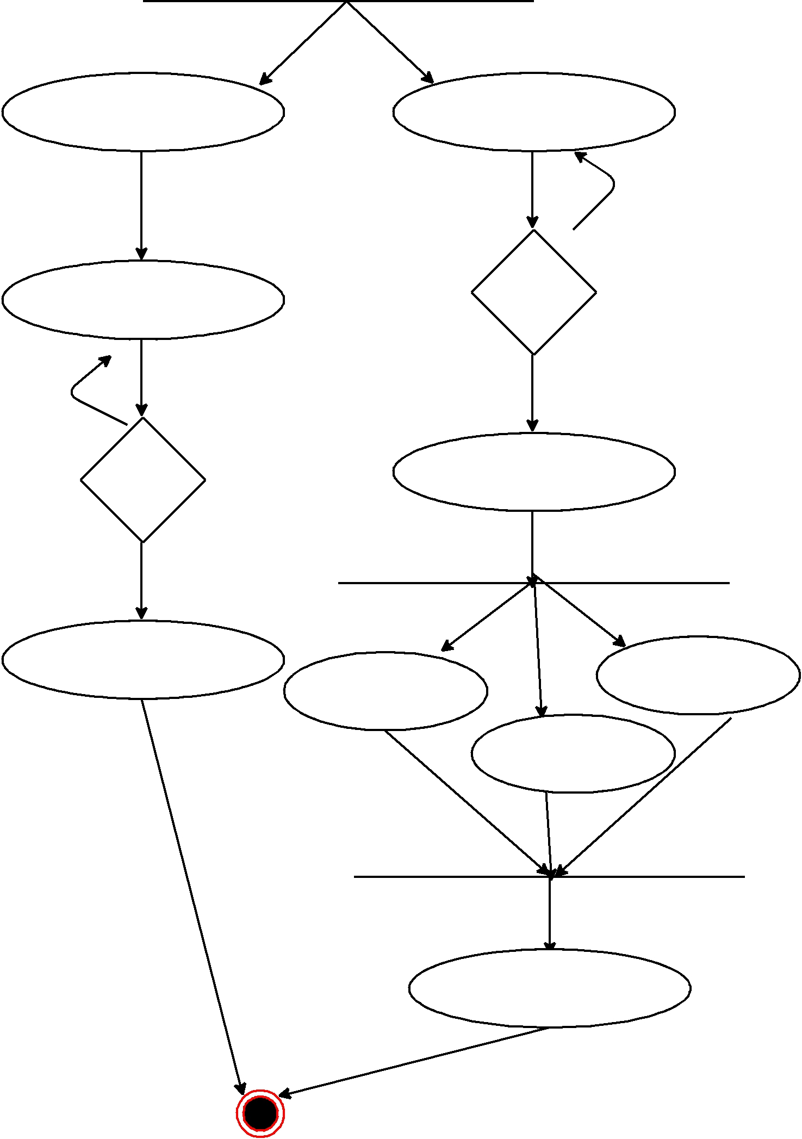

Create Account Enter Id and Password

No

All Detail

No

Yes

Valid

Detail

Choice Menu

yes

Submit
Change Pwd

Amount transfer

View Details

Finished

